S/W Development Completion Report

Project Name
Author |  | Approver
Team

Contents

1 Project Result ４
1.1 Development Period and Responsibilities ４
1.2 Project Achievements ４
1.3 Development Effect and Utilization of Results ５
2 Development History ６
2.1 Development S/W Structure ６
2.2 Development Deliverables ７
2.3 Development Environment ８

- Revision History

Version | Date | Revised contents | Author | Approver
1.0 | 19.12.2025 | Initial Release4 Completion Report; file persistence implementation | Magnus Jaaska

- Terms and Abbreviation

DLD | Detailed Level Design
SRS | Software Requirements Specification
UI | User Interface
I/O | Input/Output (file operations)
RAII | Resource Acquisition Is Initialization
CSV | Comma-Separated Values (semicolon in our case)
STL | Standard Template Library

- References

- [1] Magnus Jaaska. Currency Exchange System - Software Requirements Specification. Release 1. TalTech. October 2025.

- [2] Magnus Jaaska. Currency Exchange System - Detailed Level Design. Version 3.0. TalTech. December 2025.

- [3] TalTech. Fundamentals of C++ Programming. Course Materials. Fall 2025.

Project Result

Development Period and Responsibilities
<Specify the Development Period and the Responsibilities in Table 1-1. Development Type should be selected out of System Project, S/W Research Project, Outsourcing Project, New Development Project and Up-grade Development Project.>

Table 1-1. Development Term and Responsibilities
Development Period | October 2025 - December 2025 (3 months)
Development Type | New Development Project (Educational Project)
Responsibility | Team | Position | Name
Development PL | Compile Commander | Student/Developer | Magnus Jaaska
S/W Development PL | Compile Commander | Student/Developer | Magnus Jaaska

Project Achievements

Table 1-2. Project Achievements
Item | Achievements
Basic Achievements | Successfully implemented 4-release incremental development methodology  • Delivered fully functional currency exchange system with persistent storage  • Achieved 100% requirement coverage from SRS  • Zero critical bugs in final release
Acquired Technologies | C++ file I/O operations (ifstream, ofstream)  • Text file parsing and validation techniques  • STL containers (std::map, std::vector)  • Error handling and exception strategies  • Layered software architecture design  • UML modeling (class, sequence, activity diagrams)
Transferable Technologies | Generic file persistence layer implementation  • CSV/text file parsing framework  • Repository pattern with abstraction layer  • Defensive programming techniques for data validation
Documentation | Complete SRS (Release 1)  • Detailed Level Design (Releases 2-4)  • Mermaid UML diagrams for all major components  • Comprehensive inline code documentation

Development Effect and Utilization of Results
Development Effects:

- Educational Impact:

- Demonstrated practical application of C++ programming concepts
- Applied software engineering principles (SOLID, separation of concerns)
- Gained experience with incremental development and version control
- Practiced technical documentation writing
- Technical Benefits:

- Reusable architecture for similar data management applications
- Robust error handling framework applicable to other file I/O projects
- Clean separation of concerns enables easy maintenance and extension
- Performance:

- Fast in-memory operations during runtime
- Efficient file I/O with complete save/load in milliseconds for typical datasets
- Graceful degradation with malformed data (skip invalid lines)

- Utilization Fields:

- Financial Applications: Template for currency exchange, stock trading, or banking systems
- Data Management Systems: Generic pattern for loading/saving structured data
- Educational Projects: Reference implementation for C++ course assignments
- Small Business Tools: Foundation for point-of-sale or accounting software

Development History

Development S/W Structure
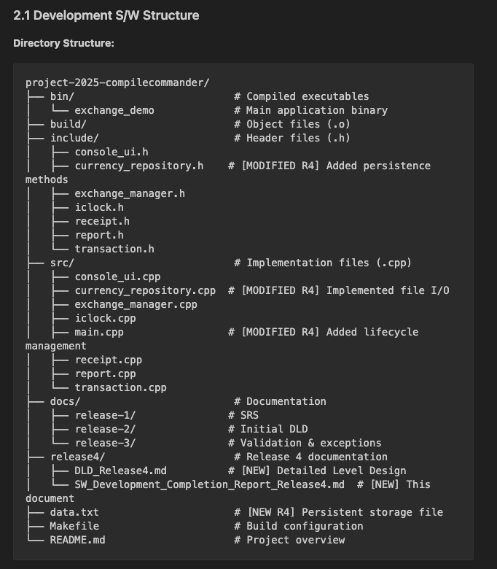

Development Deliverables
Release 1 (October 2025): Foundation & Requirements
- Software Requirements Specification (SRS)
- Project structure setup
- Makefile and build system
- Initial README documentation
Release 2 (October 2025): Architecture & Implementation
- Three-layer architecture implementation
- Repository pattern with interfaces
- Core exchange logic
- Basic UI implementation
- Detailed Level Design (DLD) v1.0
Release 3 (November 2025): Validation & Error Handling
- Input validation at all layers
- Custom exception classes (InvalidInput, InvalidData, InsufficientReserve, MissingRate)
- Exception handling policy
- Activity and sequence diagrams
- DLD v2.0 with validation rules and behavioral models
Release 4 (December 2025): Persistent Storage ⭐
- File I/O implementation:
  - loadAll(filename) - Load balances from file
  - saveAll(filename) - Save balances to file
  - parseLine() - Parse and validate file lines
  - toLine() - Format balance entries
- File format specification (semicolon-separated values)
- Defensive parsing (skip invalid lines with warnings)
- Startup/shutdown lifecycle management
- DLD v3.0 with:
  - Mermaid class diagrams
  - Activity diagrams for file operations
  - Sequence diagram for persistence lifecycle
  - File format specification
  - Architectural decision documentation
- S/W Development Completion Report (this document)
- Persistent data file (data.txt)

Development Environment

Table 2-1. Hardware Environment
Type | Operating System | Major Use | Remarks
Development PC | macOS 15.1 (Darwin 25.1.0) | Development, testing, compilation | Apple Silicon (M-series)

Table 2-2. Software Environment
Type | Model & Spec. | Major Use | Remarks
Compiler | g++ (Apple clang version 16.0.0) | C++ compilation | C++20 standard
Build System | GNU Make 3.81 | Automated build process | Makefile with targets
Version Control | Git 2.45+ | Source code management | GitHub repository
IDE | Visual Studio Code | Code editing, debugging | C++ extensions installed

